Name:
Easier
Easier

Harder
1 | Simplify:  4c + 3d -c | Simplify:  3x + 5y – 2x + 2y³ | Simplify:  10xyxy  5xy | Simplify:  12x³y²z  8y²z
2 | Simplify:  (3y)² = | Expand the brackets:  3(y + 7) = | Expand the brackets:  7(x – 5) = | Expand the brackets and then simplify the expression:  3(x – 2) – x + 4
3 | Solve:  3 + 2x = 15 | Solve:  4(x + 3) = 16 | Solve:  6x – 3 = 3x + 21 | Solve:  2(x -3) = x + 5
4 | List the factors of 24. | Factorise:  4a² – 2a | Factorise:  3x + 18 | Factorise:  2x - 12

 | RECALL
 | 435 + 229 | 638 - 249 | Calculate:  $\frac{2}{4}$ + $\frac{3}{8}$ = | Calculate:  $\frac{7}{9}$ - $\frac{2}{3}$ =
 | 23 x 36 | 453 $÷$ 3 | Calculate:  $\frac{4}{5}$ x $\frac{3}{7}$ = | Calculate:  $\frac{4}{5}$ $÷$ $\frac{2}{3}$ =
 | Convert 48mm to cm | Convert 245cm to m | 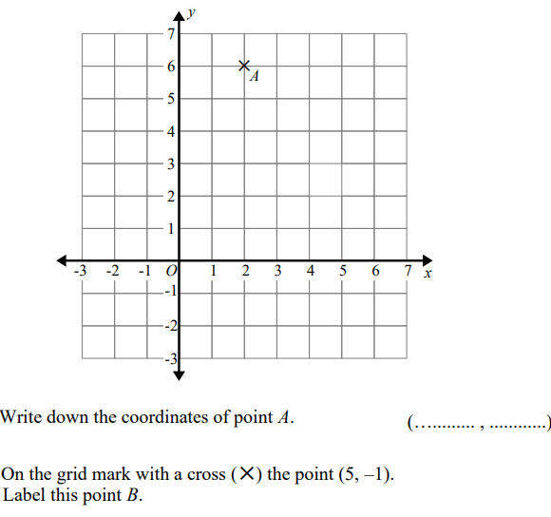
 | Convert 1.5km to m | Convert 3.6m to cm

